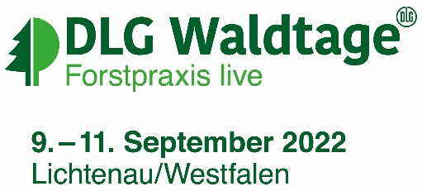
SPECIMEN INVITATION – Paper voucher

Address of your customer

08/07/2022

Invitation to DLG-Waldtage 2022

Dear customer,
We would like to invite you to DLG-Waldtage, the leading meeting point for forestry practice and a platform for sustainable, future- and use-oriented forest management, which will take place from 09 to 11 September 2022 in Lichtenau, Germany. Visit us in on Stand x.
Enclosed you will receive a voucher from us, which you can exchange online for a personal admission ticket (valid on one day between 09 - 11 September).
Important! The voucher itself is not a ticket and does not grant admission. You need to register online to obtain your personal admission ticket.
Redeeming your voucher – what to do:
1) Go online to www.dlg-waldtage.de/registration
2) Enter your voucher code and register online
3) Print out your e-ticket or save it on your smartphone
If you have any questions about the registration, you can contact the DLG-Waldtage Team directly, by e-mail to ticketing@dlg.org or by telephone at +49 69 24788-425.
We look forward to seeing you there!
Kind regards,

PS: All the information about redeeming your voucher is shown on the back of your voucher too.

